Contact: Christie Kozak | Leary PR | christie@learypr.com | 978-502-5747

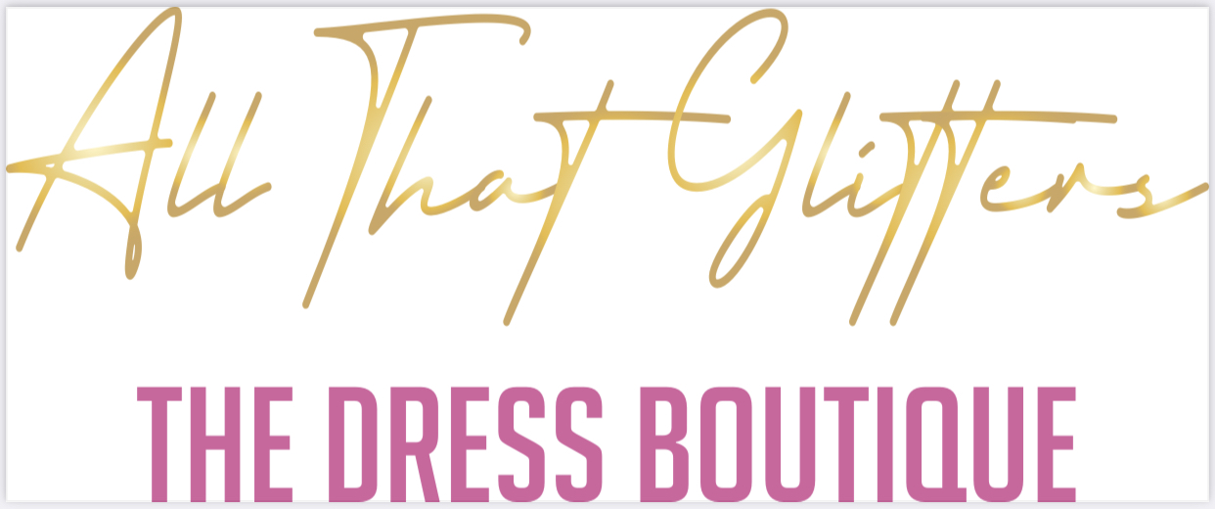

The African American Association of Brockton Opens
All That Glitters Prom Pop-Up at Westgate Mall

Accepting Donations for Prom Season for Distribution to Local Youths

BROCKTON, MASSACHUSETTS (April 2022) - Westgate Mall (ShopatWestgateMall.com) has announced the opening of All That Glitters, a Prom Pop-Up Boutique, with the African American Association of Brockton through May 2022. All That Glitters will accept donations of new or gently worn prom dresses, and prom accessories including shoes, purses, and jewelry. The Prom Pop-Up is open to Brockton teens to come and select donated prom wear, free of charge. The shop is located near Expressions in the center.

“We are extremely grateful that Westgate Mall is hosting All That Glitters. This is an important pop-up shop which will allow many Brockton youths the ability to receive prom attire which they might not have been able to afford. It’s a great way for the community to come together to support our local youths,” says Jamie Hodges, President/Founder of African American Association of Brockton.

Twin Sisters, Jamie and Jasmine Hodges founded and started Brockton's first African American Association. The Mission of the African American Association of Brockton is to enrich the lives of the residents of Brockton, Massachusetts by promoting an awareness of African American Culture through music, dance, arts, food, and community Service​.

“Westgate Mall is pleased to partner with the African American Association of Brockton to create this
special pop-up shop which will help so many of our area teens enjoy prom,” says Rebekah Macchia, Marketing Director of Westgate Mall.

Westgate Mall
Westgate Mall, an enclosed regional mall in Brockton, Massachusetts, features Burlington, Best Buy Outlet Planet Fitness, DICK’S Sporting Goods, Old Navy, and Staples, plus a mix of more than 60 specialty stores including Verizon and XFINITY Store by Comcast, Bath and Body Works, Jo-Ann Fabric and Craft Stores, Famous Footwear, The Children’s Place, and Rue21. Eateries include Chipotle, Buffalo Wild Wings, IHOP and Auntie Anne’s/Carvel/Cinnabon and more. Market Basket is also on-site. Westgate Mall is located at the intersection of Routes 24 and 27 in Brockton and accessible via the Brockton Area Transit Authority. For directions and additional information, visit ShopatWestgateMall.com. Westgate Mall is a New England Development shopping destination.

New England Development
For over forty years, New England Development has taken a creative, entrepreneurial approach to real estate development and management - delivering and sustaining successful projects across a wide range of property types. These projects transform complex challenges into preferred locations, generate long-term value to communities, afford compelling opportunities for local and national businesses, and offer sought-after experiences to a wide range of consumers.

The company is acclaimed for creating some of the country's most widely-recognized and successful regional centers, as well as multifaceted developments that combine retail, residential, hotel, and office uses. Outlet centers, high-end and street-front retail, airport retail, golf courses, restaurants, and marinas round out New England Development's robust portfolio. For more information, visit NEDevelopment.com.

# # #

