Contact:
Christie Kozak | Leary PR | christie@learypr.com | 978-502-5747

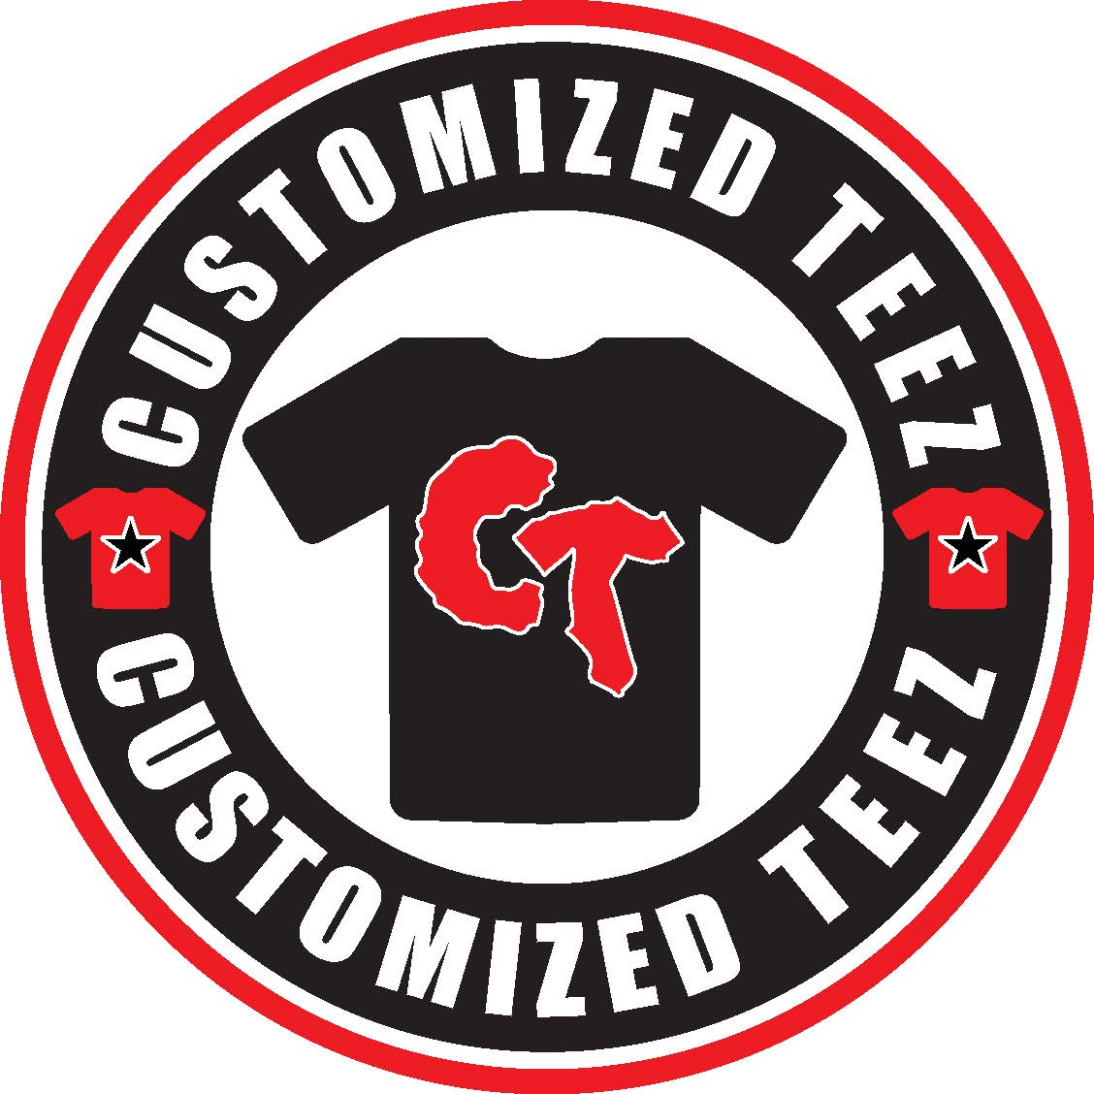

Customized Teez Expands at Westgate Mall

Offering Today’s Most Sought-After Custom Tee-Shirt Designs

BROCKTON, MASSACHUSETTS (June 2021) - Westgate Mall (ShopatWestgateMall.com) has announced the relocation of Customized Teez into new, larger space. Starting as a small kiosk at the center, Customized Teez has seen continued growth and has moved into an in-line store location near Famous Footwear. The retailer offers custom printed tee-shirts and sweatshirts featuring prints of Michael Jordan, Among Us and other popular designs.

“Westgate Mall is pleased to support Customized Teez in this new expansion at the center,” says Rebekah Macchia, Marketing Director for Westgate Mall. “Customized Teez offers a wide selection of today’s most sough-after, unique tee designs, which are favorites with shoppers,” she adds.

Westgate Mall
Westgate Mall, an enclosed regional mall in Brockton, Massachusetts, features Burlington, Planet Fitness, DICK’S Sporting Goods, Old Navy, Staples and Best Buy Outlet, plus a mix of more than 60 specialty stores including Verizon and XFINITY Store by Comcast, Bath and Body Works, Jo-Ann Fabric and Craft Stores, Famous Footwear, The Children’s Place, and Rue21. Eateries include Chipotle, Buffalo Wild Wings, IHOP and Auntie Anne’s/Carvel/Cinnabon. Market Basket is also on-site. Westgate Mall is located at the intersection of Routes 24 and 27 in Brockton and accessible via the Brockton Area Transit Authority. For directions and additional information, please call 508-588-8916 or visit ShopatWestgateMall.com. Westgate Mall is a New England Development shopping destination.

New England Development
For over forty years, New England Development has taken a creative, entrepreneurial approach to real estate development and management - delivering and sustaining successful projects across a wide range of property types. These projects transform complex challenges into preferred locations, generate long-term value to communities, afford compelling opportunities for local and national businesses, and offer sought-after experiences to a wide range of consumers.

The company is acclaimed for creating some of the country's most widely-recognized and successful regional centers, as well as multifaceted developments that combine retail, residential, hotel, and office uses. Outlet centers, high-end and street-front retail, airport retail, golf courses, restaurants, and marinas round out New England Development's robust portfolio. For more information, visit NEDevelopment.com.

# # #

