Contact:
Christie Kozak | Leary PR | christie@learypr.com | 978-502-5747

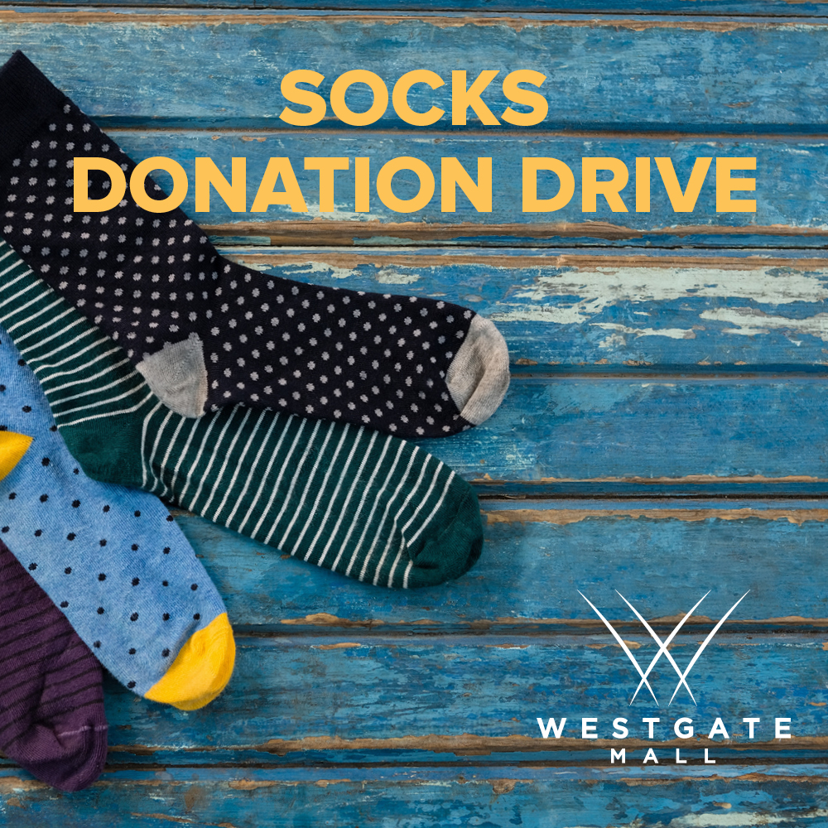

Westgate Mall Hosts Socks Donation Drive
for School on Wheels of Massachusetts

BROCKTON, MASSACHUSETTS (March 2024) – Westgate Mall has teamed with Schools on Wheels of Massachusetts to collect new, toddler, children, and adult size pairs of socks. This sock donation drive supports families experiencing homelessness. New pairs of socks can be brought to Westgate Mall and left in the donation bin at Laced through March. Laced will offer those donating socks a Buy-One-Get-One-Free (lesser or equal value, Laced items only) promotion the day of their donation. See the store for complete details. Monetary donations to Schools on Wheels can be made at SOWA.com.

"By donating new socks to children experiencing homelessness you can provide a practical and essential item that helps promote comfort, health, and well-being for families experiencing challenging times. SOWMA supports the educational needs of our students and if a child is uncomfortable, they cannot learn. We provide educational support to the children through our programs and help bring comfort items during this time of year," explains Barbara Fox, Community Outreach Director for School on Wheels.

School on Wheels
School on Wheels of Massachusetts (SOWMA) was founded in 2004 by teacher and child advocate Cheryl Opper after reading a magazine article about Agnes Stevens, Founder of School on Wheels of California. Cheryl was inspired to bring the one-on-one academic support program to Massachusetts for children impacted by homelessness. Since the start of the 2021/2022 academic year, SOWMA has distributed more than 6,000 new customized, grade-level backpacks to children and at-risk youth living in 38 Massachusetts communities. Trained volunteers provide one-on-one tutoring to 280 students at 18 program site locations from Boston to the South Coast. The Bridge Mentoring Program provides 87 high school and college-age students with financial support and mentors, who shepherd students through high school and
onto post-secondary plans, including college, vocational training, and jobs. For more information, visit SOWA.com.

Westgate Mall
Westgate Mall, an enclosed regional mall in Brockton, Massachusetts, features Burlington, Best Buy Outlet Planet Fitness, DICK’S Sporting Goods, Old Navy, and Staples, plus a mix of more than 60 specialty stores including Verizon and XFINITY Store by Comcast, Bath and Body Works, Famous Footwear, The Children’s Place, and Rue21. Eateries include Chipotle, IHOP and Auntie Anne’s/Carvel/Cinnabon and more. Market Basket is also on-site. Westgate Mall is located at the intersection of Routes 24 and 27 in Brockton and accessible via the Brockton Area Transit Authority. For directions and additional information, visit ShopatWestgateMall.com. Westgate Mall is a New England Development shopping destination.

New England Development
For over 40 years, New England Development has taken a creative, entrepreneurial approach to real estate development and management, delivering, and sustaining successful projects across a wide range of property types. The company’s national portfolio includes mixed-use developments that combine retail, residential, office, lab and hotel use, outlet centers, high-end and street-front retail, airport retail, hotels, golf courses, restaurants, and marinas. New England Development’s diverse portfolio includes CambridgeSide in Cambridge, MA, Chestnut Hill Square in Chestnut Hill, MA, Outlets of Des Moines in Altoona, IA, Clarksburg Premium Outlets in Clarksburg, MD, Newburyport Development and Marinas, Nantucket Island Retail and The White Elephant Resorts, among others. For more information, visit NEDevelopment.com.

# # #

