Contact:
Christie Kozak | Leary PR | christie@learypr.com | 978-502-5747

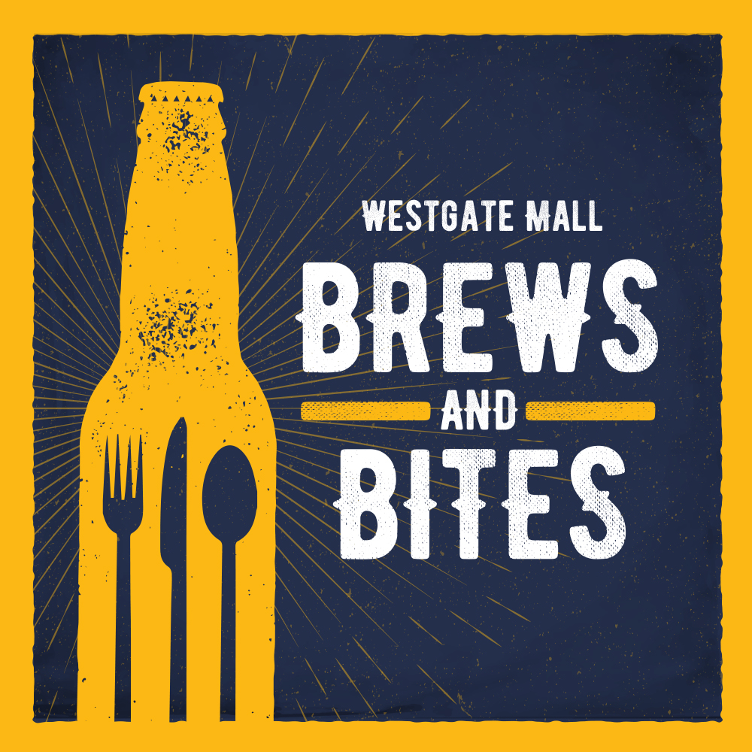

Brews + Bites Food Truck and Craft Beer Festival
Returns to Westgate Mall

Saturday, September 24, 2022 from Noon to 5:00 p.m.

BROCKTON, MASSACHUSETTS (September 2022) - Westgate Mall will host Brews + Bites Food Truck and Craft Beer Festival on Saturday, September 24 from Noon to 5:00 p.m. at the center. The event will feature many local food trucks, craft breweries and hard cider. The afternoon will have a fun, family-friendly atmosphere filled not only with delicious food and beverage options, but giveaways, games, live music and more.

There is no admission charge to attend; each food truck will price and serve their fare independently. Craft beer, hard cider and sangria will also be available for purchase.

“We are excited to once again host Brews + Bites, a wonderful day at the center to enjoy live music, delicious bites from local food trucks, and craft beers and ciders from our local brewers,” says Rebekah Macchia, Marketing Director for Westgate Mall.

Participating food trucks and breweries include:

Food Trucks:
Lady C & J Soul Food
Mom on the Go
The Friendly Fizz
The Sausage Guy

Breweries:
Artifact Cider
Black Hat Brew Works
Brockton Beer Company
The Sangria Lady

Live Music:
Scott Damgaard

Westgate Mall
Westgate Mall, an enclosed regional mall in Brockton, Massachusetts, features Burlington, Best Buy Outlet Planet Fitness, DICK’S Sporting Goods, Old Navy, and Staples, plus a mix of more than 60 specialty stores including Verizon and XFINITY Store by Comcast, Bath and Body Works, Jo-Ann Fabric and Craft Stores, Famous Footwear, The Children’s Place, and Rue21. Eateries include Chipotle, Buffalo Wild Wings, IHOP and Auntie Anne’s/Carvel/Cinnabon and more. Market Basket is also on-site. Westgate Mall is located at the intersection of Routes 24 and 27 in Brockton and accessible via the Brockton Area Transit Authority. For directions and additional information, visit ShopatWestgateMall.com. Westgate Mall is a New England Development shopping destination.

New England Development
For over forty years, New England Development has taken a creative, entrepreneurial approach to real estate development and management - delivering and sustaining successful projects across a wide range of property types. These projects transform complex challenges into preferred locations, generate long-term value to communities, afford compelling opportunities for local and national businesses, and offer sought-after experiences to a wide range of consumers.

The company is acclaimed for creating some of the country's most widely recognized and successful regional centers, as well as multifaceted developments that combine retail, residential, hotel, and office uses. Outlet centers, high-end and street-front retail, airport retail, golf courses, restaurants, and marinas round out New England Development's robust portfolio. For more information, visit NEDevelopment.com.

# # #

