Contact:
Christie Kozak | Leary PR | christie@learypr.com | 978-502-5747

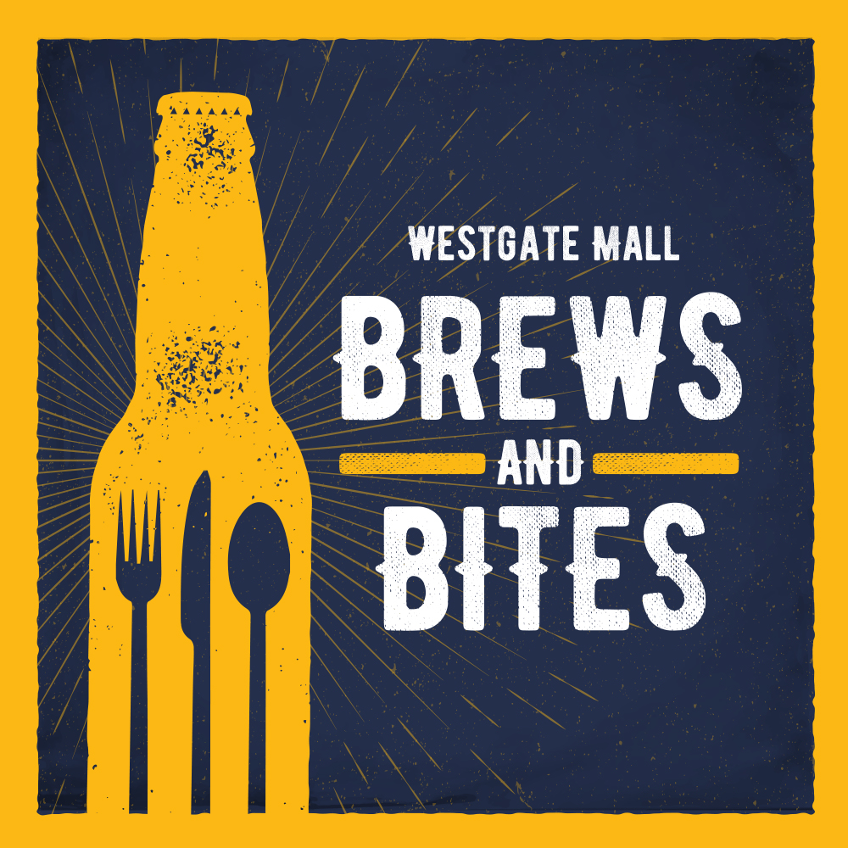

Westgate Mall to Host Annual
Brews + Bites Food Truck and Craft Beer Festival

Saturday, September 30, 2023, 12 noon to 5:00 p.m.

BROCKTON, MASSACHUSETTS (September 2023) - Westgate Mall will host Brews + Bites Food Truck and Craft Beer Festival presented by Planet Fitness on Saturday, September 30, 2023, from 12 noon to 5:00 p.m. The fun, family-friendly afternoon will feature delicious local food trucks, area breweries, giveaways, games, live music and more. There is no admission charge to attend; each vendor will price and serve their fare independently. Craft beer and sangria will also be available for purchase.

“Westgate Mall is looking forward to host our much-anticipated Brews + Bites Food Truck and Craft Beer Festival, an exciting family friendly event with live music and delicious food and beverage options,” says Rebekah Macchia, Marketing Director for Westgate Mall.

Participating food trucks and breweries include:

Food Trucks:
Across the Border Food Truck
Deag’s Local Diner + Food Truck
Ellie’s Sweet Treats
Lady C & J Soul Food
Mom on the Go
Papi’s Stuffed Sopapillas
The Friendly Fizz
The Sausage Guy

Breweries:
Barrel House Z
Brockton Beer Company
The Sangria Lady
Second Wind Brewing Company

Live Music:
Kooked Out

For complete details and information regarding participating breweries and food trucks, visit
ShopatWestgateMall.com. (Please note vendors subject to change.)

Westgate Mall
Westgate Mall, an enclosed regional mall in Brockton, Massachusetts, features Burlington, Best Buy Outlet Planet Fitness, DICK’S Sporting Goods, Old Navy, and Staples, plus a mix of more than 60 specialty stores including Verizon and XFINITY Store by Comcast, Bath and Body Works, Famous Footwear, The Children’s Place, and Rue21. Eateries include Chipotle, IHOP and Auntie Anne’s/Carvel/Cinnabon and more. Market Basket is also on-site. Westgate Mall is located at the intersection of Routes 24 and 27 in Brockton and accessible via the Brockton Area Transit Authority. For directions and additional information, visit ShopatWestgateMall.com. Westgate Mall is a New England Development shopping destination.

New England Development
For over forty years, New England Development has taken a creative, entrepreneurial approach to real estate development and management - delivering and sustaining successful projects across a wide range of property types. These projects transform complex challenges into preferred locations, generate long-term value to communities, afford compelling opportunities for local and national businesses, and offer sought-after experiences to a wide range of consumers. The company is acclaimed for creating some of the country's most widely recognized and successful regional centers, as well as multifaceted developments that combine retail, residential, hotel, and office uses. Outlet centers, high-end and street-front retail, airport retail, golf courses, restaurants, and marinas round out New England Development's robust portfolio. For more information, visit NEDevelopment.com.

# # #

