Contact:
Christie Kozak | Leary PR | christie@learypr.com | 978-502-5747

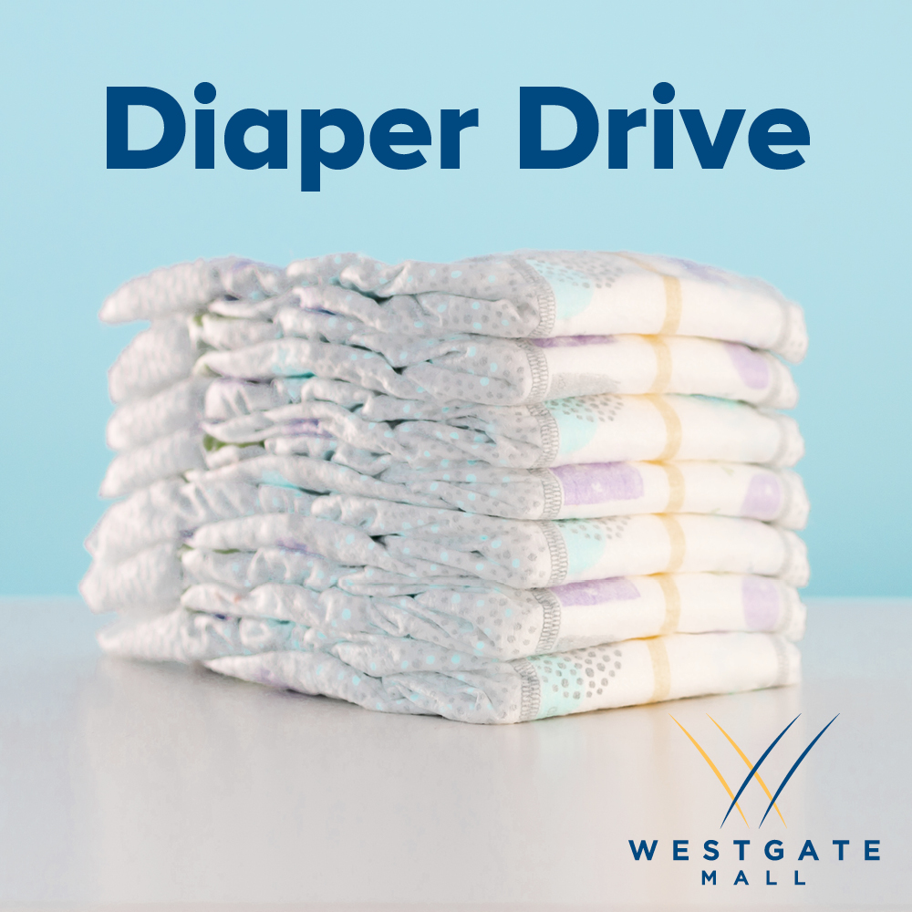

Westgate Mall Hosts Diaper Donation Drive
for The Salvation Army of Brockton

BROCKTON, MASSACHUSETTS (May 2022) - Westgate Mall has partnered with The Salvation Army of Brockton to host a Diaper Donation Drive. Donations of diapers and baby wipes will be accepted throughout the month of May in the specially marked bin near Burlington. To make a monetary donation, please visit SalvationArmyMA.org/Brockton.

“One in three families in the United States, many of whom are living in poverty, find themselves in diaper need. You can help today through the donation of baby diapers and baby wipes,” says Lt. Meghan Labrecque of The Salvation Army in Brockton.

“Westgate Mall continues to partner with The Salvation Army of Brockton to support ongoing needs of the local community. We are pleased to host this important diaper donation drive that will directly impact families in need,” says Rebekah Macchia, Director of Marketing for Westgate Mall. For more information, visit ShopatWestgateMall.com.

The Salvation Army
The Salvation Army annually helps more than 30 million Americans overcome poverty, addiction, and economic hardships through a range of social services. By providing food for the hungry, emergency relief for disaster survivors, rehabilitation for those suffering from drug and alcohol abuse, and clothing and shelter for people in need, The Salvation Army is doing the most good at 7,600 centers of operation around the country. In the first-ever listing of "America’s Favorite Charities” by The Chronicle of Philanthropy, The Salvation Army ranked as the country’s largest privately funded, direct-service nonprofit. For more information, visit SalvationArmyMA.org. Follow us on Twitter @SalvationArmyMA and #DoingTheMostGood.

Westgate Mall
Westgate Mall, an enclosed regional mall in Brockton, Massachusetts, features Burlington, Best Buy Outlet Planet Fitness, DICK’S Sporting Goods, Old Navy, and Staples, plus a mix of more than 60 specialty stores including Verizon and XFINITY Store by Comcast, Bath and Body Works, Jo-Ann Fabric and Craft Stores, Famous Footwear, The Children’s Place, and Rue21. Eateries include Chipotle, Buffalo Wild Wings, IHOP and Auntie Anne’s/Carvel/Cinnabon and more. Market Basket is also on-site. Westgate Mall is located at the intersection of Routes 24 and 27 in Brockton and accessible via the Brockton Area Transit Authority. For directions and additional information, visit ShopatWestgateMall.com. Westgate Mall is a New England Development shopping destination.

New England Development
For over forty years, New England Development has taken a creative, entrepreneurial approach to real estate development and management - delivering and sustaining successful projects across a wide range of property types. These projects transform complex challenges into preferred locations, generate long-term value to communities, afford compelling opportunities for local and national businesses, and offer sought-after experiences to a wide range of consumers.

The company is acclaimed for creating some of the country's most widely-recognized and successful regional centers, as well as multifaceted developments that combine retail, residential, hotel, and office uses. Outlet centers, high-end and street-front retail, airport retail, golf courses, restaurants, and marinas round out New England Development's robust portfolio. For more information, visit NEDevelopment.com.

# # #

