Contact: Christie Kozak | Leary PR | christie@learypr.com | 978-502-5747

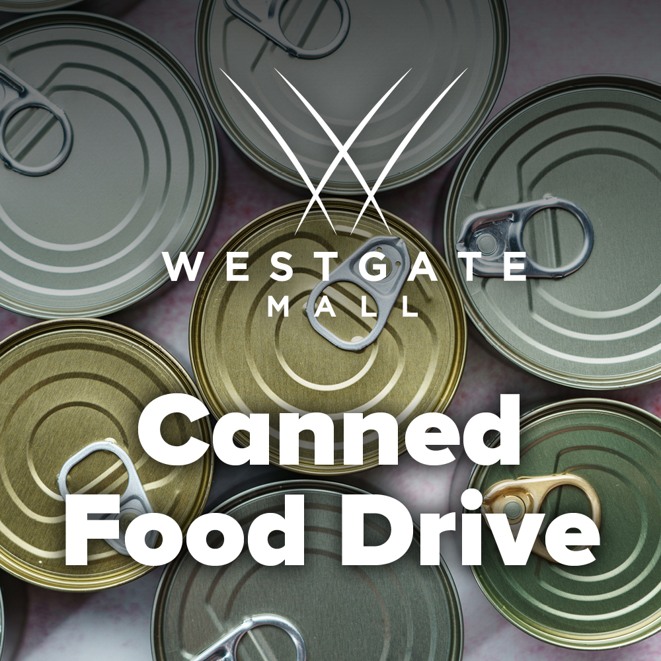

Westgate Mall Holds Canned Food Drive Benefiting
The Salvation Army of Brockton

BROCKTON, MASSACHUSETTS (November 2023) - Westgate Mall (ShopatWestgateMall.com) is hosting a Canned Food Drive to benefit The Salvation Army of Brockton. Items collected will be used for inclusion in Thanksgiving Baskets for local families in need, as well as items to help stock the shelves of their food pantry.

Suggested donation items include canned pumpkin, dried potatoes, stuffing, mac and cheese, canned vegetables, and more. Donations can be dropped off at Fusion Dolls in the center through November 19, 2023. To make a monetary donation to The Salvation Army of Brockton visit SalvationArmyMa.org/Brockton. For a full list of requested items, visit ShopatWestgateMall.com.

“We are grateful to Westgate Mall for partnering with The Salvation Army to ensure that everyone has a meal to put on their table this Thanksgiving. With increasing requests for assistance, this is a time when our communities can come together to help our neighbors in need,” says Lt. Stephen Rivero, The Salvation Army of Brockton.

“Westgate Mall is pleased to support The Salvation Army of Brockton on this annual donation drive. This important drive helps so many in our local Brockton community,” says Rebekah Macchia, Marketing Director of Westgate Mall.

About The Salvation Army
The Salvation Army annually helps 25 million Americans overcome poverty, addiction, and economic hardships through a range of social services. By providing food for the hungry, emergency relief for disaster survivors, rehabilitation for those suffering from drug and alcohol abuse, and clothing and shelter for people in need, The Salvation Army is doing the most good at over 7,000 centers of operation around the country. During times of disaster, 100 percent of designated donations to The Salvation Army are used for immediate response and long-term efforts. In the first-ever listing of “America’s Favorite Charities” by The Chronicle of Philanthropy, The Salvation Army ranked as the country’s largest privately funded, direct-service nonprofit. For more information, visit SalvationArmyMA.org. Follow us on X @SalvationArmyMA and #DoingTheMostGood.

Westgate Mall
Westgate Mall, an enclosed regional mall in Brockton, Massachusetts, features Burlington, Best Buy Outlet Planet Fitness, DICK’S Sporting Goods, Old Navy, and Staples, plus a mix of more than 60 specialty stores including Verizon and XFINITY Store by Comcast, Bath and Body Works, Famous Footwear, The Children’s Place, and Rue21. Eateries include Chipotle, IHOP and Auntie Anne’s/Carvel/Cinnabon and more. Market Basket is also on-site. Westgate Mall is located at the intersection of Routes 24 and 27 in Brockton and accessible via the Brockton Area Transit Authority. For directions and additional information, visit ShopatWestgateMall.com. Westgate Mall is a New England Development shopping destination.

New England Development
For over forty years, New England Development has taken a creative, entrepreneurial approach to real estate development and management - delivering and sustaining successful projects across a wide range of property types. These projects transform complex challenges into preferred locations, generate long-term value to communities, afford compelling opportunities for local and national businesses, and offer sought-after experiences to a wide range of consumers.

The company is acclaimed for creating some of the country's most widely recognized and successful regional centers, as well as multifaceted developments that combine retail, residential, hotel, and office uses. Outlet centers, high-end and street-front retail, airport retail, golf courses, restaurants, and marinas round out New England Development's robust portfolio. For more information, visit NEDevelopment.com.

# # #

