**Contact:**

Christie Kozak | Leary PR | [christie@learypr.com](mailto:christie@learypr.com) | 978-502-5747

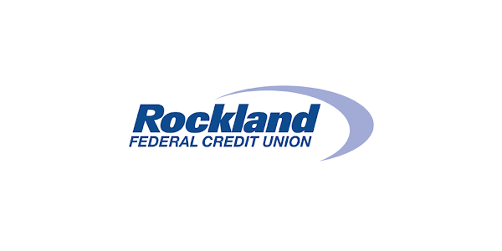

**Westgate Mall Announces Opening of Rockland Federal Credit Union**

BROCKTON, MASSACHUSETTS (August 2024) - Westgate Mall ([ShopatWestgateMall.com](https://www.shopatwestgatemall.com/)) has announced the opening of Rockland Federal Credit Union, offering personal and business banking solutions including high-interest checking account options, savings accounts, mortgages, business line of credits and more.

"We are thrilled to announce the opening of our new branch at the Westgate Mall in Brockton, MA. This expansion reflects our ongoing commitment to providing convenient, personalized banking services to our members. We look forward to serving the Brockton community and helping our members achieve their financial goals,” states Kris VanBeek, CEO, Rockland Federal Credit Union.

**Rockland Federal Credit Union**

Rockland Federal Credit Union (RFCU) is a community-focused, non-profit financial institution proudly owned by its members. Profits are reinvested, benefiting members with competitive rates and lower fees. Dedicated to exceptional customer service and community involvement, RFCU offers a wide array of financial products and services to qualifying members. RFCU’s mission is to ensure the financial well-being of its members by providing reliable and personalized banking solutions, and by supporting members’ financial journeys every step of the way. For more information, visit [RFCU.com](http://www.rfcu.com/).

**Westgate Mall**

Westgate Mall, an enclosed regional mall in Brockton, Massachusetts, features Burlington, Best Buy Outlet Planet Fitness, DICK’S Sporting Goods, Old Navy, and Staples, plus a mix of more than 60 specialty stores including Verizon and XFINITY Store by Comcast, Bath and Body Works, Famous Footwear, and The Children’s Place. Eateries include Chipotle, IHOP, Auntie Anne’s/Carvel/Cinnabon, and more. Market Basket is also on-site. Westgate Mall is located at the intersection of Routes 24 and 27 in Brockton and accessible via the Brockton Area Transit Authority. For directions and additional information, visit [ShopatWestgateMall.com](https://www.shopatwestgatemall.com/). Westgate Mall is a New England Development shopping destination.

**New England Development**

For over 50 years, New England Development has taken a creative, entrepreneurial approach to real estate development and management, delivering and sustaining successful projects across a wide range of property types. The company’s national portfolio includes mixed-use developments that combine retail, residential, office, lab and hotel use, outlet centers, high-end and street-front retail, airport retail, hotels, golf courses, restaurants, and marinas. New England Development’s diverse portfolio includes CambridgeSide in Cambridge, MA, Allston Yards in Allston, MA, Chestnut Hill Square in Chestnut Hill, MA, Outlets of Des Moines in Altoona, IA, Clarksburg Premium Outlets in Clarksburg, MD, Newburyport Development and White Elephant Resorts, among others. For more information, visit [NEDevelopment.com](https://nedevelopment.com/).

# # #