**Contact:**

Christie Kozak | Leary PR | [christie@learypr.com](mailto:christie@learypr.com) | 978-502-5747

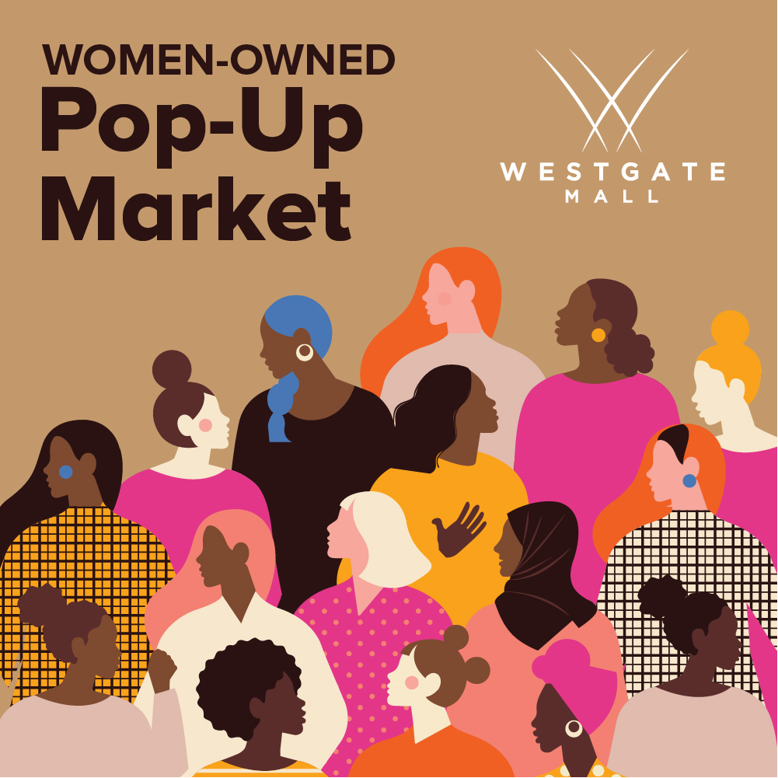

**Pop-Up Market Celebrates Women’s History Month**

**Hosted by Westgate Mall and Black Owned Brockton**

***Saturday, March 25, 2023***

BROCKTON, MASSACHUSETTS (March 2023) – In recognition of Women’s History Month, Westgate Mall together with Black Owned Brockton will host a Pop-Up Market Saturday, March 25, 2023, from 12:00 p.m. to 6:00 p.m. The ongoing partnership with Black Owned Brockton is part of Westgate Mall’s commitment to promote local businesses.

Shoppers will find an array of unique products including art, jewelry, home décor and more from local women-owned businesses. Vendors include Queen’s Lane Collection, True Beauty Beads LLC, Handmade by Rita, Sam’s Sweet Treats and more. The Pop-Up Market will be located near GNC in the center.

"March is designated as National Women's History Month. We use this time to highlight women's many essential and overlooked contributions in advancing the City of Brockton community. We are delighted to partner with Westgate Mall again to bring the city a women-based shopping experience. The Pop-Up Market celebrates Greater Brockton's Black Women business owners and features self-care products, community and family fun," says Shaleah Gilmer, Executive Director, Founder.

“We encourage shoppers to support these talented local women-owned businesses as we celebrate Women’s History Month,” says Rebekah Macchia, Marketing Director of Westgate Mall. For more information, visit [ShopatWestgateMall.com](https://www.shopatwestgatemall.com/).

**Black Owned Brockton**

With over 1,000 members and supporters throughout the City of Brockton, Black Owned Brockton was launched in June 2020 as a business advocacy organization. Black Owned Brockton’s mission is to bridge the opportunity divide by ensuring that local black and brown small businesses in Brockton gain visibility, access to resources and consistent support that will empower and improve economic sustainability. For more information, visit [BlackOwnedBrockton.com](http://www.blackownedbrockton.com).

**Westgate Mall**

Westgate Mall, an enclosed regional mall in Brockton, Massachusetts, features Burlington, Best Buy Outlet PlanetFitness, DICK’S Sporting Goods, Old Navy, and Staples, plus a mix of more than 60 specialty stores including Verizon and XFINITY Store by Comcast, Bath and Body Works, Famous Footwear, The Children’s Place, and Rue21. Eateries include Chipotle, IHOP and Auntie Anne’s/Carvel/Cinnabon and more. Market Basket is also on-site. Westgate Mall is located at the intersection of Routes 24 and 27 in Brockton and accessible via the Brockton Area Transit Authority. For directions and additional information, visit [ShopatWestgateMall.com](https://www.shopatwestgatemall.com/). Westgate Mall is a New England Development shopping destination.

**New England Development**

For over forty years, New England Development has taken a creative, entrepreneurial approach to real estate development and management - delivering and sustaining successful projects across a wide range of property types. These projects transform complex challenges into preferred locations, generate long-term value to communities, afford compelling opportunities for local and national businesses, and offer sought-after experiences to a wide range of consumers. The company is acclaimed for creating some of the country's most widely-recognized and successful regional centers, as well as multifaceted developments that combine retail, residential, hotel, and office uses. Outlet centers, high-end and street-front retail, airport retail, golf courses, restaurants, and marinas round out New England Development's robust portfolio. For more information, visit [NEDevelopment.com](http://www.NEDevelopment.com).

# # #