**Contact:**

Christie Kozak | Leary PR | [christie@learypr.com](mailto:christie@learypr.com) | 978-502-5747

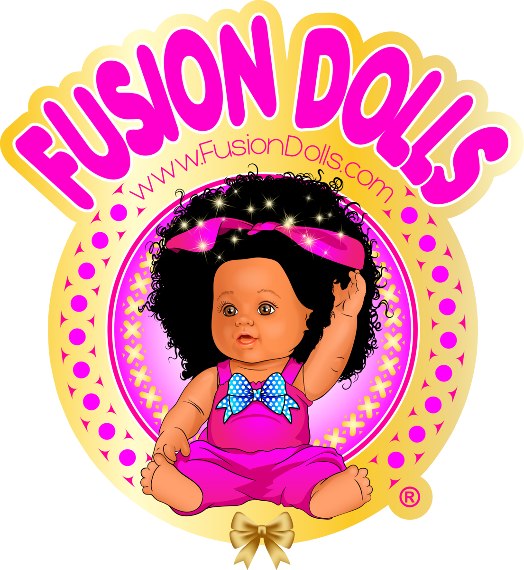

**Fusion Dolls at Westgate Mall Named Entrepreneur of the Year**

**by the Metro South Chamber of Commerce**

***Promoting Self-Love with Multicultural Dolls***

BROCKTON, MASSACHUSETTS (May 2021) – Fusion Dolls at Westgate Mall in Brockton ([ShopatWestgateMall.com](https://www.shopatwestgatemall.com/)) will be recognized by the Metro South Chamber of Commerce as Entrepreneur of the Year at the live virtual Small Business Awards on Thursday, May 14, 2021 via Zoom Pro. The program will include guest speaker Keiko Matsudo Orrall, Executive Director of the Massachusetts Office of Travel and Tourism as well as the Mayor of Brockton, Massachusetts Office of Business Development, and U.S. Small Business Administration spokespersons.

A Black, woman owned business, Fusion Dolls creates dolls and accessories that are multicultural. The doll maker celebrates diversity, providing girls with dolls that look like them. Fusion Dolls is owned by Widline Pyrame, who came to the United States from Haiti as a teenager.

From an early age, Widline noticed that toys and media imagery predominately showcased fair complexion women. Becoming a social worker, she recognized the importance of children having dolls that look like them to learn about self-love and acceptance. Visit Fusion Dolls at Westgate Mall; for more information and to view a full catalog of Fusion Dolls, visit [FusionDolls.com](https://fusiondolls.com/) or Facebook and Instagram [@fusiondolls](https://www.instagram.com/fusiondolls/).

“Westgate Mall congratulates Widline Pyrame and Fusion Dolls on being named Entrepreneur of the Year by the Metro South Chamber of Commerce, a well-deserved designation for a true innovator,” says Rebekah Macchia, Marketing Director of Westgate Mall. “We invite shoppers to see these amazing dolls at Westgate Mall,” she adds.

**Westgate Mall**

Westgate Mall, an enclosed regional mall in Brockton, Massachusetts, features Burlington, PlanetFitness, DICK’S Sporting Goods, Old Navy, Staples, Sears, and Best Buy Outlet (coming soon), plus a mix of more than 60 specialty stores including Verizon and XFINITY Store by Comcast, Bath and Body Works, Jo-Ann Fabric and Craft Stores, Famous Footwear, The Children’s Place, and Rue21. Eateries include Chipotle, Buffalo Wild Wings, IHOP and Auntie Anne’s/Carvel/Cinnabon. Market Basket is also on-site. Westgate Mall is located at the intersection of Routes 24 and 27 in Brockton and accessible via the Brockton Area Transit Authority. For directions and additional information, please call 508-588-8916 or visit [ShopatWestgateMall.com](https://www.shopatwestgatemall.com/). Westgate Mall is a New England Development shopping destination.

**New England Development**

For over forty years, New England Development has taken a creative, entrepreneurial approach to real estate development and management - delivering and sustaining successful projects across a wide range of property types. These projects transform complex challenges into preferred locations, generate long-term value to communities, afford compelling opportunities for local and national businesses, and offer sought-after experiences to a wide range of consumers.

The company is acclaimed for creating some of the country's most widely-recognized and successful regional centers, as well as multifaceted developments that combine retail, residential, hotel, and office uses. Outlet centers, high-end and street-front retail, airport retail, golf courses, restaurants, and marinas round out New England Development's robust portfolio. For more information, visit [NEDevelopment.com](http://www.NEDevelopment.com).

# # #