**Contact:**

Christie Kozak | Leary PR | [christie@learypr.com](mailto:christie@learypr.com) | 978-502-5747

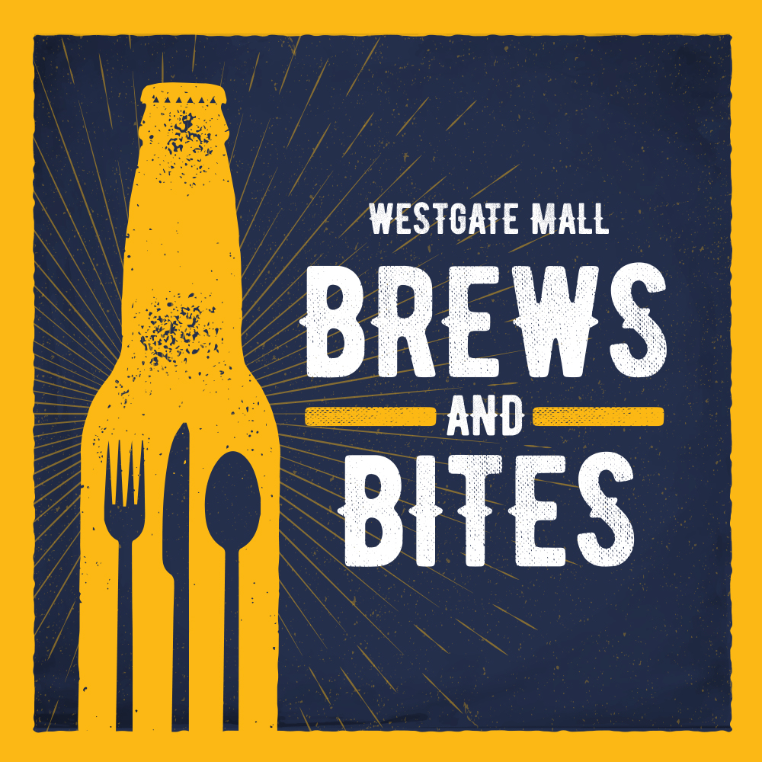

**Westgate Mall Hosts Annual Brews & Bites**

**Food Truck and Craft Beer Festival**

**Saturday, September 28, 2024, from 12 Noon to 5:00 p.m.**

BROCKTON, MASSACHUSETTS (September 2024) – Westgate Mall will host Brews & Bites Food Truck and Craft Beer Festival on Saturday, September 28, 2024, from 12 noon to 5:00 p.m. featuring a selection of local food trucks, craft brews, games, live music and more.

Sponsored by Rockland Federal Credit Union and Planet Fitness, the family friendly event is free and open to the public; each vendor will price and serve their fare independently. Brews & Bites is dog friendly and will be held rain or shine. Covered seating will be available for attendees. For more information, visit [ShopatWestgateMall.com](https://www.shopatwestgatemall.com/).

 Participating food trucks include:

[La Qchara](https://laqchara.com/) - Latin-American tacos, arepas, tortas, burritos, and bowls.

[Lady C & J Soul Food](https://ladycjcatering.com/) - BBQ Soul Food.

[Moyzilla](https://www.moyzillaboston.com/) - Asian comfort food – handmade dumplings, Japanese fried chicken, noodles.

[Mr. Frosty](https://www.frostyicecream.com/) -Ice Cream.

[The Chubby Chickpea](https://www.thechubbychickpea.com/) - Mediterranean favorites like chicken shawarma and falafel.

[Work Hard Eat Good](https://www.workhardeatgood.com/food_truck_menu-service/) - Caribbean comfort food including jerk chicken, curry chicken, Caribbean steak tips and more. A second Work Hard Eat Good truck will be serving comfort food including grilled cheese and hot dogs.

Participating breweries include:

[90+ Cellars](https://www.ninetypluscellars.com/)

[Brockton Beer Company](https://www.brocktonbeer.com/" \t "_blank)

[Shovel Town Brewery](https://www.shoveltownbrewery.com/" \t "_blank)

“Westgate Mall’s Annual Brews & Bites Food Truck and Craft Beer Festival offers an exciting selection of foods and beverages for every taste. It’s a fun filled day of entertainment for the whole family,” says Rebekah Macchia, Marketing Director for Westgate Mall.

**Westgate Mall**

Westgate Mall, an enclosed regional mall in Brockton, Massachusetts, features Burlington, Best Buy Outlet, Planet Fitness, DICK’S Sporting Goods, Old Navy, and Staples, plus a mix of more than 60 specialty stores including Verizon and XFINITY, Bath and Body Works, Famous Footwear, and The Children’s Place. Eateries include Chipotle, IHOP, Auntie Anne’s/Carvel/Cinnabon, and more. Market Basket is also on-site. Westgate Mall is located at the intersection of Routes 24 and 27 in Brockton and accessible via the Brockton Area Transit Authority. For directions and additional information, visit [ShopatWestgateMall.com](https://www.shopatwestgatemall.com/). Westgate Mall is a New England Development shopping destination.

**New England Development**

For over 50 years, New England Development has taken a creative, entrepreneurial approach to real estate development and management, delivering and sustaining successful projects across a wide range of property types. The company’s national portfolio includes mixed-use developments that combine retail, residential, office, lab and hotel use, outlet centers, high-end and street-front retail, airport retail, hotels, golf courses, restaurants, and marinas. New England Development’s diverse portfolio includes CambridgeSide in Cambridge, MA, Allston Yards in Allston, MA, Chestnut Hill Square in Chestnut Hill, MA, Outlets of Des Moines in Altoona, IA, Clarksburg Premium Outlets in Clarksburg, MD, Newburyport Development and White Elephant Resorts, among others. For more information, visit [NEDevelopment.com](https://nedevelopment.com/).

# # #