Contact:
Christie Kozak | Leary PR | christie@learypr.com | 978-502-5747

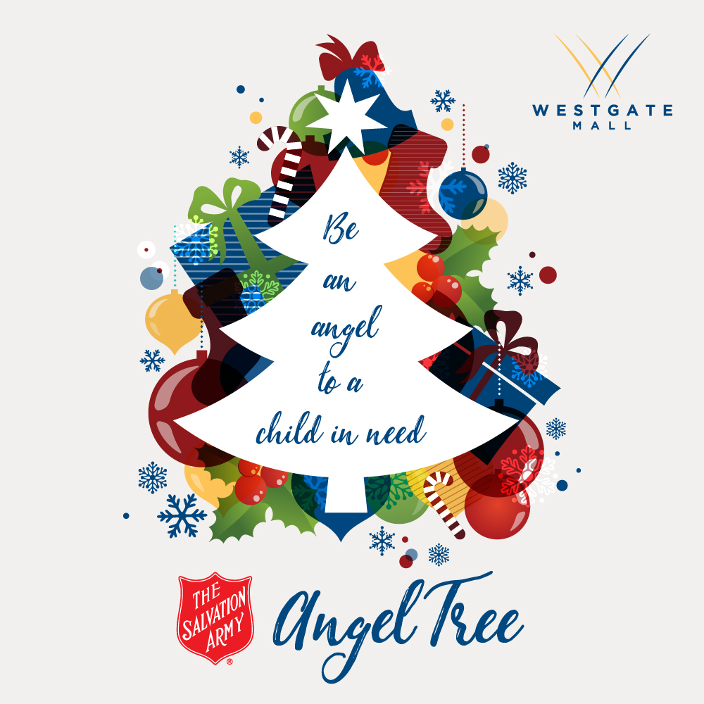

Westgate Mall to Host The Salvation Army Angel Tree

Make a Child’s Holiday Wishes Come True -
Donations Accepted through December 10, 2021

BROCKTON, MASSACHUSETTS (November 2021) - Westgate Mall (ShopatWestgateMall.com) will host The Salvation Army of Brockton’s Annual Angel Tree now through December 10, 2021. Located near Burlington, the Angel Tree is adorned with ornaments featuring a child’s name, age and special gift wish. Select an ornament and provide a helping hand to area families in need.

“The Salvation Army is facing another challenging holiday season to meet the increasing needs of people struggling to provide for their families. We are thankful for our community and partners like the Westgate Mall that help us spread joy during the Christmas season by providing gifts to kids,” says Lt. Meghan Labrecque
Corps Officer, Brockton Citadel Corps of The Salvation Army Massachusetts Division.

After selecting a child’s name from the Westgate Mall Angel Tree, please bring new, unwrapped gifts to the Mall Management Office or drop-off with Security by December 10, 2021. Monetary donations can also be made at SalvationArmyMA.org/Brockton. Gifts will be distributed by The Salvation Army to children before the holidays.

“Westgate Mall is pleased support The Salvation Army of Brockton’s Angel Tree program which annually helps bring joy to children in need. Our center is proud of our longstanding partnership with The Salvation Army of Brockton to host numerous drives throughout the year to help the local community. We are very grateful to our shoppers for their participation in this special donation drive,” says Rebekah Macchia, Marketing Director of Westgate Mall.

Westgate Mall
Westgate Mall, an enclosed regional mall in Brockton, Massachusetts, features Burlington, Best Buy Outlet Planet Fitness, DICK’S Sporting Goods, Old Navy, and Staples, plus a mix of more than 60 specialty stores including Verizon and XFINITY Store by Comcast, Bath and Body Works, Jo-Ann Fabric and Craft Stores, Famous Footwear, The Children’s Place, and Rue21. Eateries include Chipotle, Buffalo Wild Wings, IHOP and Auntie Anne’s/Carvel/Cinnabon and more. Market Basket is also on-site. Westgate Mall is located at the intersection of Routes 24 and 27 in Brockton and accessible via the Brockton Area Transit Authority. For directions and additional information, visit ShopatWestgateMall.com. Westgate Mall is a New England Development shopping destination.

New England Development
For over forty years, New England Development has taken a creative, entrepreneurial approach to real estate development and management - delivering and sustaining successful projects across a wide range of property types. These projects transform complex challenges into preferred locations, generate long-term value to communities, afford compelling opportunities for local and national businesses, and offer sought-after experiences to a wide range of consumers.

The company is acclaimed for creating some of the country's most widely-recognized and successful regional centers, as well as multifaceted developments that combine retail, residential, hotel, and office uses. Outlet centers, high-end and street-front retail, airport retail, golf courses, restaurants, and marinas round out New England Development's robust portfolio. For more information, visit NEDevelopment.com.

# # #

