**Contact:**

Christie Kozak | Leary PR | [christie@learypr.com](mailto:christie@learypr.com) | 978-502-5747

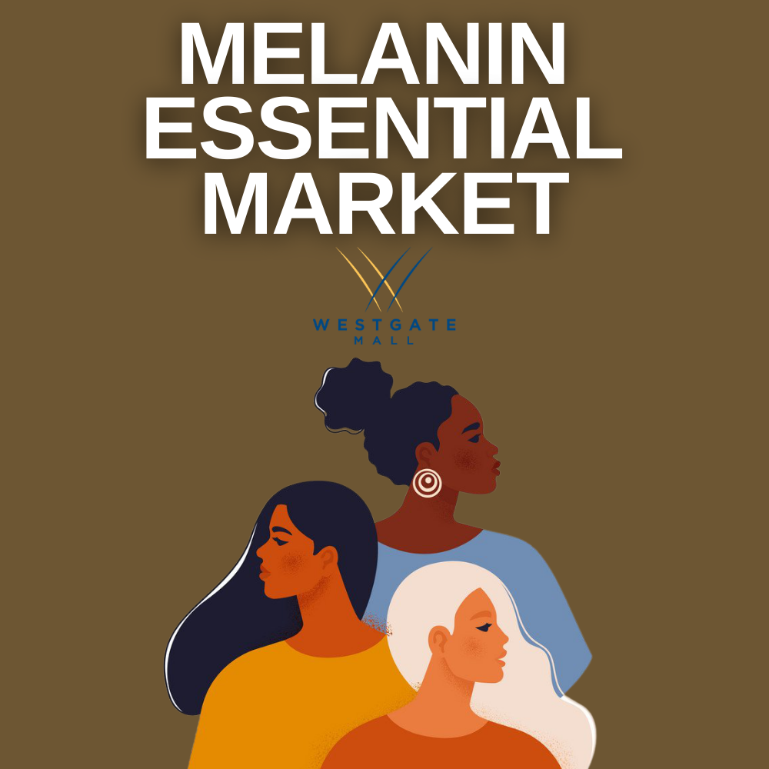

**Westgate Mall Hosts**

**Black Owned Brockton Pop-Up**

***Friday, June 18 through Sunday, June 20, 2021***

BROCKTON, MASSACHUSETTS (June 2021) – Westgate Mall in Brockton will partner with Black Owned Brockton to host a Melanin Essential Market Pop-Up featuring a variety of local entrepreneurs showcasing curated art, apparel, beauty products, home goods, specialty food, gifts and more. Over twenty-five vendors will be in attendance including Clock Whyse: Aromatherapy Essential Spray, Jelly Bean Sweets, Baked Goods, Lady C&J, Soul Food Catering and Fab Fit Forever: Sports & Fitness Apparel, among others.

The Melanin Essential Market Pop-Up will be held at Westgate Mall on Friday, June 18 from 12:00 p.m. to

7:00 p.m.; Saturday, June 19 from 11:00 a.m. to 7:00 p.m.; and Sunday, June 20 from 12:00 p.m. to 6:00 p.m. For more information, visit [ShopatWestgateMall.com](https://www.shopatwestgatemall.com/).

Black Owned Brockton was launched in June 2020 as a business advocacy organization. With over 1,000 members and supporters throughout the City of Brockton, Black Owned Brockton’s mission is to bridge the opportunity divide by ensuring that local black and brown small businesses in Brockton gain visibility, access to resources and consistent support that will empower and improve economic sustainability.  For more information, visit [www.BlackOwnedBrockton.com](http://www.blackownedbrockton.com).

“We are pleased to present the Melanin Essential Market Pop-Up, the first in a series of vendor markets in partnership with Black Owned Brockton at Westgate Mall,” says Rebekah Macchia, Marketing Director of Westgate Mall. “We are looking forward to the weekend pop-up and encourage visitors to support these local businesses,” she adds.

**Westgate Mall**

Westgate Mall, an enclosed regional mall in Brockton, Massachusetts, features Burlington, PlanetFitness, DICK’S Sporting Goods, Old Navy, Staples, and Best Buy Outlet, plus a mix of more than 60 specialty stores including Verizon and XFINITY Store by Comcast, Bath and Body Works, Jo-Ann Fabric and Craft Stores, Famous Footwear, The Children’s Place, and Rue21. Eateries include Chipotle, Buffalo Wild Wings, IHOP and Auntie Anne’s/Carvel/Cinnabon. Market Basket is also on-site. Westgate Mall is located at the intersection of Routes 24 and 27 in Brockton and accessible via the Brockton Area Transit Authority. For directions and additional information, please call 508-588-8916 or visit [ShopatWestgateMall.com](https://www.shopatwestgatemall.com/). Westgate Mall is a New England Development shopping destination.

**New England Development**

For over forty years, New England Development has taken a creative, entrepreneurial approach to real estate development and management - delivering and sustaining successful projects across a wide range of property types. These projects transform complex challenges into preferred locations, generate long-term value to communities, afford compelling opportunities for local and national businesses, and offer sought-after experiences to a wide range of consumers.

The company is acclaimed for creating some of the country's most widely-recognized and successful regional centers, as well as multifaceted developments that combine retail, residential, hotel, and office uses. Outlet centers, high-end and street-front retail, airport retail, golf courses, restaurants, and marinas round out New England Development's robust portfolio. For more information, visit [NEDevelopment.com](http://www.NEDevelopment.com).

# # #