Contact:
Christie Kozak | Leary PR | christie@learypr.com | 978-502-5747

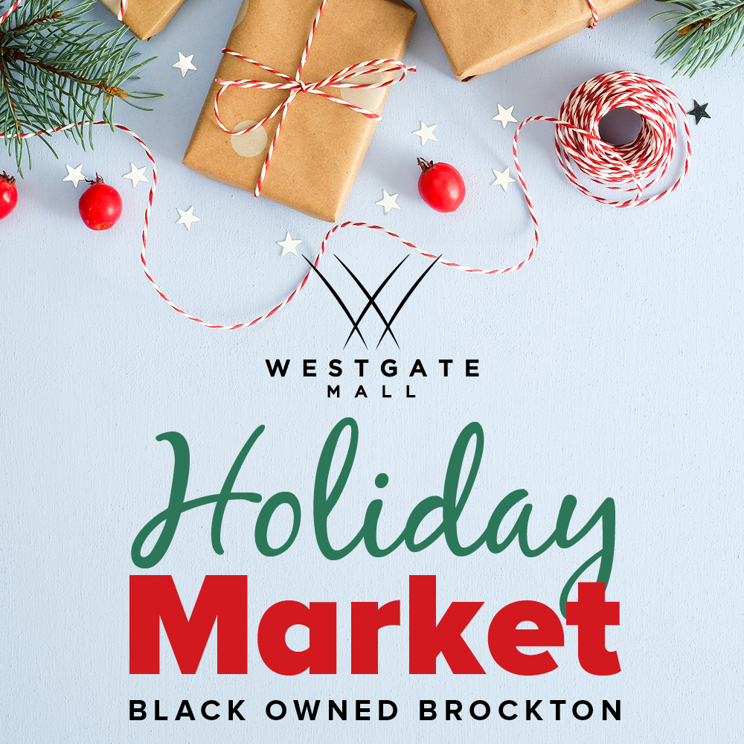

Westgate Mall Hosts Holiday Pop-Up Markets
In Partnership with Black Owned Brockton

BROCKTON, MASSACHUSETTS (November 2021) – Westgate Mall will host a series of Holiday Pop-Up Markets in partnership with Black Owned Brockton starting November 19, 2021, and running through Christmas Eve, December 24, 2021 on select days and times. Shoppers will find a rotating selection of vendors featuring unique gift items including curated art, apparel, beauty products, home décor, specialty food, and more.

The Black Owned Brockton Holiday Pop-Up Markets at Westgate Mall are part of an ongoing commitment by the center to promote the works of talented local businesses of color. These markets provide an opportunity for the community to support these local businesses, while giving shoppers access to unique and distinctive holiday gifts. For more information on dates and a full vendor participant list, visit
ShopatWestgateMall.com.

“It has been a pleasure working with Westgate Mall throughout this year to create a cohesive, collaborative environment for local black and minority business owners. We've had the opportunity to connect with a substantial number of new businesses and shoppers. Black Owned Brockton is very excited to be a part of the Westgate Mall community for the holidays. We welcome family and friends to join us in closing out 2021 strong celebrating the holidays, entrepreneurship in Brockton and our advancement as a community," says Shaleah Gilmer, Founder of Black Owned Brockton.

Black Owned Brockton was launched in June 2020 as a business advocacy organization. With over 1,000 members and supporters throughout the City of Brockton, Black Owned Brockton’s mission is to bridge the opportunity divide by ensuring that local black and brown small businesses in Brockton gain visibility, access to resources and consistent support that will empower and improve economic sustainability. For more information, visit BlackOwnedBrockton.com.

“The holidays are a perfect time to support local entrepreneurs,” says Rebekah Macchia, Marketing Director of Westgate Mall. “We are pleased to continue our successful partnership with Black Owned Brockton and encourage our shoppers to support these locally owned businesses who feature many one-of-a-kind items,” she adds.

Westgate Mall
Westgate Mall, an enclosed regional mall in Brockton, Massachusetts, features Burlington, Best Buy Outlet Planet Fitness, DICK’S Sporting Goods, Old Navy, and Staples, plus a mix of more than 60 specialty stores including Verizon and XFINITY Store by Comcast, Bath and Body Works, Jo-Ann Fabric and Craft Stores, Famous Footwear, The Children’s Place, and Rue21. Eateries include Chipotle, Buffalo Wild Wings, IHOP and Auntie Anne’s/Carvel/Cinnabon and more. Market Basket is also on-site. Westgate Mall is located at the intersection of Routes 24 and 27 in Brockton and accessible via the Brockton Area Transit Authority. For directions and additional information, visit ShopatWestgateMall.com. Westgate Mall is a New England Development shopping destination.

New England Development
For over forty years, New England Development has taken a creative, entrepreneurial approach to real estate development and management - delivering and sustaining successful projects across a wide range of property types. These projects transform complex challenges into preferred locations, generate long-term value to communities, afford compelling opportunities for local and national businesses, and offer sought-after experiences to a wide range of consumers.

The company is acclaimed for creating some of the country's most widely-recognized and successful regional centers, as well as multifaceted developments that combine retail, residential, hotel, and office uses. Outlet centers, high-end and street-front retail, airport retail, golf courses, restaurants, and marinas round out New England Development's robust portfolio. For more information, visit NEDevelopment.com.

# # #

