Contact:
Christie Kozak | Leary PR | christie@learypr.com | 978-502-5747

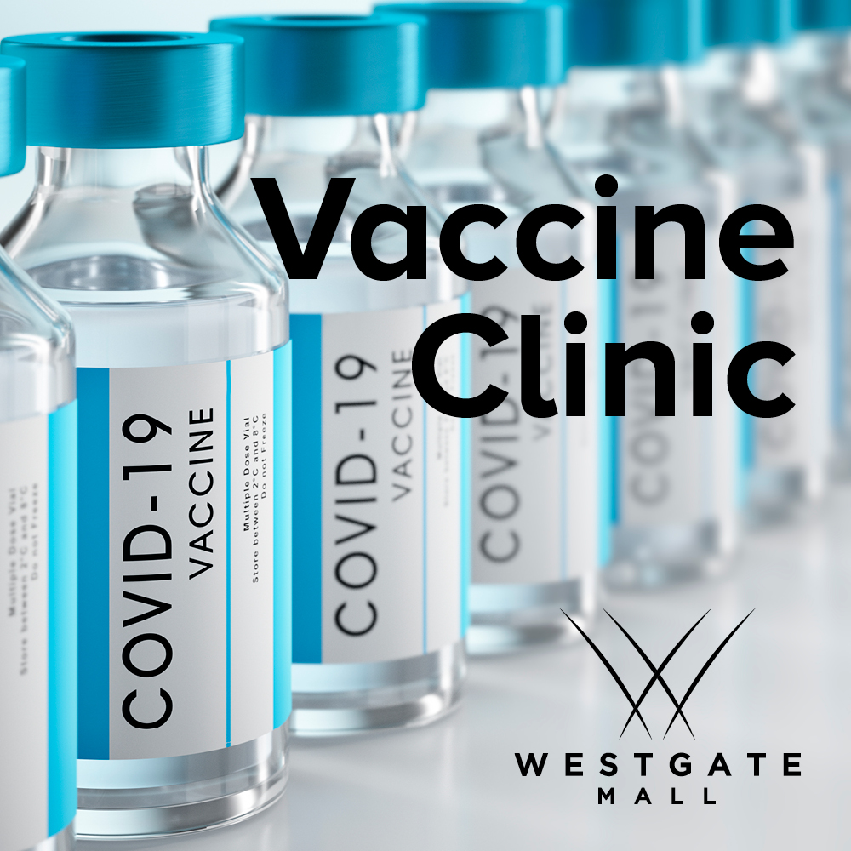

Westgate Mall to Host COVID-19 Vaccine Clinic
in partnership with Curative

Saturday, August 7 and Sunday, August 29, 2021

BROCKTON, MASSACHUSETTS (August 2021) - Westgate Mall (ShopatWestgateMall.com) will host two free COVID-19 vaccine clinics in partnership with Curative. The clinics will be held on Saturday, August 7 and Sunday, August 29, 2021 from 10:00 a.m. to 2:00 p.m.; no appointment is necessary. Both the Pfizer and Johnson & Johnson vaccinations will be offered. COVID-19 testing will also be available.

“Westgate Mall is pleased to partner with Curative, a leader in accessible health care provision, to offer free COVID-19 vaccines this August,” says Rebekah Macchia, Marketing Director for Westgate Mall.

Curative
Founded by Fred Turner, Isaac Turner, and Vlad Slepnev in January 2020, Curative was initially set up to develop a new sepsis test. When the pandemic escalated in March 2020, we decided to focus on creating a rapidly scalable COVID-19 testing process to help flatten the curve and save lives. Since then, we have been partnering with communities across the US to provide testing through turn-key programs, streamlined patient experiences, and scalable infrastructure, making health services easier to access for everyone. For more information, visit Curative.com.

Westgate Mall
Westgate Mall, an enclosed regional mall in Brockton, Massachusetts, features Burlington, Best Buy Outlet Planet Fitness, DICK’S Sporting Goods, Old Navy, and Staples, plus a mix of more than 60 specialty stores including Verizon and XFINITY Store by Comcast, Bath and Body Works, Jo-Ann Fabric and Craft Stores, Famous Footwear, The Children’s Place, and Rue21. Eateries include Chipotle, Buffalo Wild Wings, IHOP and Auntie Anne’s/Carvel/Cinnabon and more. Market Basket is also on-site. Westgate Mall is located at the intersection of Routes 24 and 27 in Brockton and accessible via the Brockton Area Transit Authority. For directions and additional information, visit ShopatWestgateMall.com. Westgate Mall is a New England Development shopping destination.

New England Development
For over forty years, New England Development has taken a creative, entrepreneurial approach to real estate development and management - delivering and sustaining successful projects across a wide range of property types. These projects transform complex challenges into preferred locations, generate long-term value to communities, afford compelling opportunities for local and national businesses, and offer sought-after experiences to a wide range of consumers.

The company is acclaimed for creating some of the country's most widely-recognized and successful regional centers, as well as multifaceted developments that combine retail, residential, hotel, and office uses. Outlet centers, high-end and street-front retail, airport retail, golf courses, restaurants, and marinas round out New England Development's robust portfolio. For more information, visit NEDevelopment.com.

# # #

